Assignment 2.2 - Data Modeling

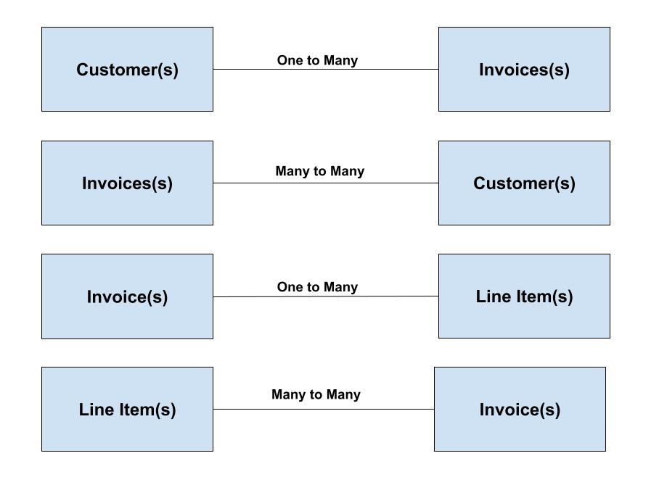

**1.**

{

_id: 012345

firstName: Joe

lastName: Coolridge

dateOfBirth: 10/15/1963

username: JoeCool

Invoice: {

_id: 012345

createDate: 01/03/2024

shipDate: 01/06/2024

subtotal: $25.50

}

}

**2.**

{

_id: 012345

createDate: 01/25/2024

shipDate: 02/24/2024

subtotal: $30.75

customer: {

_id: 45654

firstName: John

lastName: Black

dateOfBirth: 11/25/1997

username: MrProgram

}

**3.**

{

_id: 98765

createDate: 03/03/2024

shipDate: 03/16/2024

subtotal: $105.50

lineItem: {

id: 00001

productName: paperclip

price: .05

qty: 20

}

**4.**

{

id: 00002

productName: pen

price: .50

qty: 10

invoice: {

_id: 98765

createDate: 10/17/2024

shipDate: 10/22/2024

subtotal: $50

}

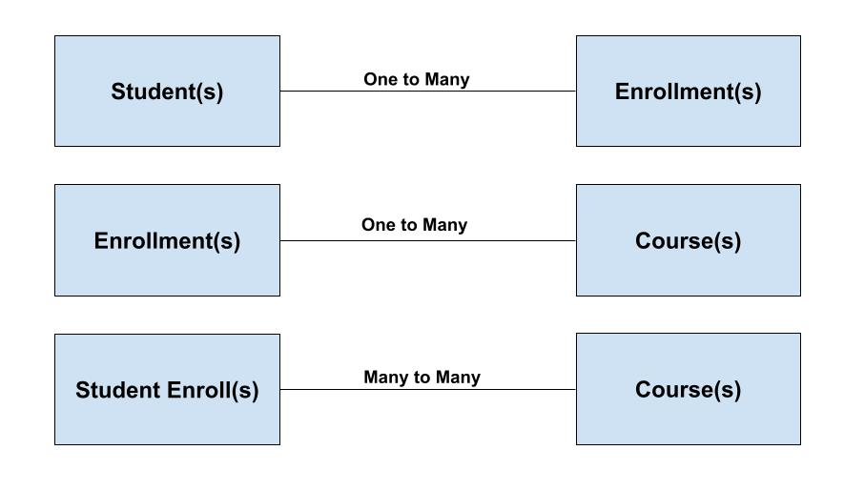

**1.**

{

studentID: 0001234

firstName: Billy

lastName: Johnson

enrollment: {

term: spring 2024

gpa: 3.5

startDate: 4/15/2024

endDate: 6/15/2024

}

**2.**

{

term: summer 2024

gpa: 3.8

startDate: 7/25/2024

endDate: 9/3/2024

Courses: {

courseid: MATH-255

description: Advanced Mathematics

instructor: Sarah Moore

score: 94

letterGrade: A

}

**3.**

studentId: 0002546

firstName: Eugene

lastName: Givens

Course: {

courseid: HIST-458

description: World History

instructor: Tiffany Greene

score: 88

letterGrade: B+

}